The Mechanics of Pitching
Beginner or experienced pitcher…fundamentals are important
by Gerald Warner, Softball Pitching Instructor, Denver, Colorado


We have often seen that pitchers, even those who have extensive experience, have often learned a “wrong” way of doing some part of the pitching motion or delivery, and consequently might have developed habits that can limit their ability and success…or even cause injuries. In many areas of pitching there is no “right” or “wrong” way of doing something, but instead a method needs to be chosen that best fits a pitcher’s personal ability and comfort-level.


However, with the fundamental “mechanics” of pitching, most qualified pitching instructors will agree that most of what we have listed below are the recommended procedures.

IMPORTANT: There are a lot of steps to learn here. Don’t try to perfect all of them at once. Take things one at a time. Nobody learns the basic mechanics overnight…take plenty of time to learn and practice each step.

MECHANICS FIRST – Learn, practice, and develop good pitching mechanics first...do NOT worry about throwing strikes when you are learning how to pitch. Learn how to do it right, make certain that everything is correct and smooth, then later you can start adding speed. Control (throwing strikes) should not be an issue in the beginning. First learn the correct way of doing the pitching motion and delivery. Then LATER you can work on being accurate and throwing strikes.

BEFORE PITCHING – Always do a pre-practice pre-pitching routine. Pitchers who don’t take adequate time to properly get ready to throw the ball run the risk of injuring themselves, and always pitch slower and with less accuracy. A good preparation always involves (1) Jogging (to loosen tight body muscles), (2) Stretching (arms, legs, hamstrings, throwing arm shoulder, and midsection…stomach/abs and lower back) for several minutes, (3) Loosen the throwing arm by starting with easy Overhand throws from a shorter distance (4) gradually working back to a Longer Distance and harder overhand throwing. Then, do the same thing underhanded: (5) Short distance underhand pitching, then gradually working back to (6) Full-distance, Full-speed pitching.

PRESENTATION – Although this doesn’t have anything to do with “mechanics” of pitching, this is a good time to discuss how to properly approach the pitching rubber. Most softball leagues and sanctioning associations require girl pitchers to approach the pitching rubber from behind (the side away from the batter) to prepare for a pitch. So now is the time to get used to doing it. Step up to the rubber from behind, and with your hands apart, at your side…a good idea is to have the ball in one hand, the glove on the other. This is called the “presentation”… showing the batter that you have the ball and are getting ready to pitch.

Mechanics of Pitching – page 2


STANCE – Take a stance on the pitching rubber that is comfortable…standing tall, with your shoulders back, and your feet far enough apart for you to be balanced, hands at your side (ball in one, glove on the other), and your neck and upper body muscles feeling totally relaxed. The feet must be placed where the league and softball sanctioning associations require them to be. Typically that means that the front (throwing arm side) “push-off” foot must be placed at the front of the pitching rubber, and at least half of it must be on the surface of the rubber. The rear (or “stride”) glove-side foot can be behind the rubber. But with some leagues, the ASA, the NCAA and others, the toe of the rear foot must at least touching the rear edge of the pitching rubber.

GRIP– Although there is no definite right or wrong way for a beginning pitcher to hold the ball, she should develop habits now in preparation for pitches that she will be developing later. Therefore, we recommend that every pitcher start by using a “4-seam” grip…one that will cause the pitched ball to rotate top-to-bottom with all four seams cutting the air. For the basic 4-seam grip, place the pads of your fingers on the seams on the side of the “U” (horseshoe).

VISUALIZE – As you are standing on the pitching rubber getting ready to start your motion, take a second to try to “see” in your mind the path that the ball will take when you throw it. Although this is not really part of basic “mechanics” it is a good idea to get used to the idea of visualizing the trajectory of the ball… from the point that you will be releasing it alongside your hip…all the way into the catcher’s mitt. The concept of “creative visualization” can eventually also assist in your fielding, throwing, and hitting.

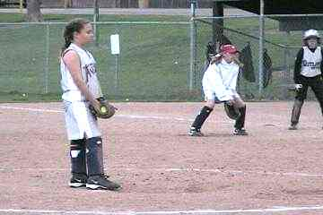
BRING THE BALL AND GLOVE TOGETHER – This is the part that follows the “Presentation” of the ball that we mentioned previously. Up to this point, your pre-pitch stance has kept your hands at your side. Most softball leagues and associations require that the ball and the glove must touch together (usually at least for one second) before starting the pitching motion. We recommend that you make the ball-glove contact close to where your hands have been hanging…in front of you, and below your waist.

STARTING THE MOTION - Although many pitchers have developed a habit of a lot of extra motion into the pre-pitch routine, bring your hands way above your head or bending over at this point are simply extra movement and energy that is being used, that will not really affect the speed or control of the pitch. We recommend…especially for beginning pitchers…that you start with your hands low, keep the ball-glove touch below the waist, and then go right directly into your backswing.

BACK-SWING – The speed or height of your backswing are not important. Do what you feel is comfortable. Typically, most pitchers will bring the ball out of their glove and swing back to a point where the arm is approximately level. If it feels more comfortable, take the arm back at a somewhat slower speed. The only time arm speed counts is when it is going forward, especially during the final downswing just before the release point.

Mechanics of Pitching – page 3

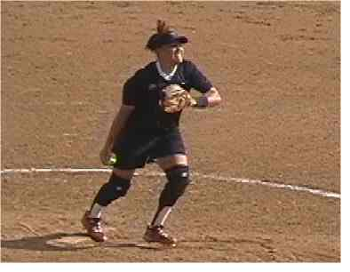
FORWARD MOVEMENT…WEIGHT TRANSFER – After your arm does its backswing, as it starts coming forward, so will your body. The purpose of the “body lean” (described elsewhere on this website) is to start the transfer of your body weight from your rear leg to the forward “push off” foot.

THE PUSH OFF - It will be the push against the front edge of the pitching rubber that starts the drive outward, the long step, and the resulting speed of the pitch.

CLOSED-OPEN-CLOSED – This is the most difficult part of learning to pitch. When you are standing on the pitching rubber facing the catcher, you are in a “closed” position (imagine yourself as a door as seen by the catcher…you are “closed”). But then, as you take the long step forward, approximately halfway through your arm rotation you will be in an “open” position…totally sideways to the catcher. Then as the arm comes down in the final swing toward the release, the upper body, then the hips will start to “close”. However, as you will read below, the hips should only be approximately halfway closed at the precise release point of the ball. Then, after the release, the hips will continue to close, allowing the pitcher to finish in the “ready” position…facing the batter.

THE STRIDE – The step that you take with your glove-side foot is often referred to as the “stride”. Although there is much disagreement among pitching instructors on this issue, we have found that in most cases, those pitchers who have a longer (and faster) stride throw a better fastball.
(NOTE FOR BEGINNING PITCHERS: Wait a while before your start practicing with a longer stride. Practice the basic mechanics of pitching first…you can start lengthening the size of your step several weeks or months from now.)

How long should the stride be? Although this is something that must be right for the pitcher, a typical stride for a leaping-style pitcher is 90% to 120% of her height. We encourage our
pitchers to stride five inches or more beyond their height. Therefore, a 5’6” pitcher will often stride 6 feet or more.

NO “LEAPING” – All pitchers will either take a long step or “leap” out to get better distance. However, all organizations sponsoring girls softball do not allow a pitcher to become airborne during the pitch…it is illegal to have both feet in the air at the same time. That is why pitchers who use a “leaping” style must also “drag” the toe of the push-off foot on the ground until the stride foot touches down. Typically, this toe drag will be on inside of the toe of the shoe, and will make an arc pattern in the dirt starting at the pitching rubber and continuing toward the glove side for a foot or more.

ARM ROTATION – As the arm comes forward, keep it relaxed and straight…but not stiff. The arm speed should be consistent and fast the whole way around (Eventually, you will learn to add an “arm whip”… accelerating the arm during the final portion of the armswing just before the release. But do NOT practice the arm whip yet). As the arm is making the circle, your body will usually go to an open (sideways) position and then will start closing as you approach the release of the pitch.

Mechanics of Pitching – page 4

NO BOBBLE HEAD - During this entire arm circle and closed-open-closed sequence, do NOT let your head move sideways. As much as you can, keep your head straight…not stiff…just straight. We often find that if a right-handed pitcher’s head tilts left, the pitch goes to the right.

THE RELEASE – There are several important things that need to happen as the arm swings down toward the release point…and they need to happen at the same time:

- Keep the wrist back as your arm approaches the release point so it can “snap” forward at the precise instant you release the ball.
- Keep your arm outstretched, but not stiff, as you release the ball. Do not allow your elbow to bend more than 15 or 20 degrees.
- “Snapping” – Although you might have been told to “snap” o NOT try to snap your wrist forward at this point. It can cause timing problems, and often cause you to pitch high.
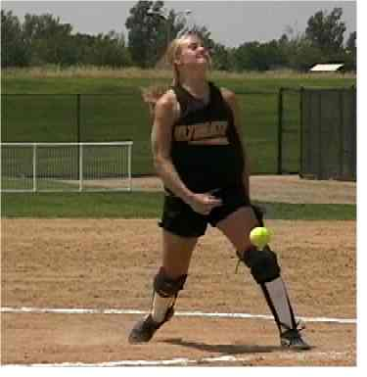
- Fingers behind the ball – You can get better speed and control if your fingers are behind the ball as it leaves your hand. We often tell pitchers to think of it as “pointing the inside of your wrist toward the catcher.” Some pitchers are taught to “roll the ball over” as it is being released in order to get a slight curve or drop on the fastball…but we recommend against that. The “over-the-top” release is often used by men pitchers. We do NOT recommend it for our students, and feel it could be injurious to young or smaller pitchers.
- Stay tall at the release. Bring your shoulders back as your pitching arm starts its final downswing toward the release point, so you can be upright and tall at the finish. Do NOT bend at the waist. Bending slows down pitching speed, and often causes pitches to go high.
- Keep your shoulders level as you release the pitch…no dipping down on the throwing-arm side.

THE FOLLOW-THROUGH – This is another of those areas where pitching instructors often have differing opinions. Our recommendation is to let the arm go where it wants to naturally. At the instant the ball has left your hand, allow your arm to relax, bend, and follow through straight ahead. For most pitchers who use the fingers-behind-the-ball and inside-of-the-wrist-toward-the-catcher method, the arm will bend slightly, then follow though straight ahead (not across the body) with the pitching hand finishing up somewhere waist-high or above, and moving toward the bicep or shoulder.

SO, THERE YOU HAVE IT. That’s a list of more than 20 things that you need to train your mind and body to do in a period of less than 2 seconds. Again, don’t try to do everything at once! Many pitchers with years of experience are still trying to learn…or at least correct…some of the things that are mentioned above. Learn one or two of these items… practice them, and make them part of your habit. THEN, go on to learn, practice, and develop a couple more.

GOOD MECHANICS means good pitching. Make it work for you.

If you have questions or need more information, E-mail us at: gw@pitchsoftball.com or call us at (720) 200-4575

